Le vernissage, partie un

PRIX TTC

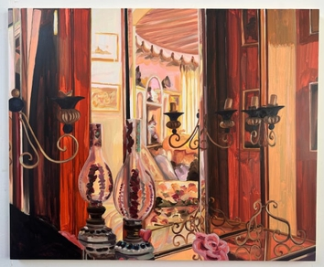 | Anna Freeman Bentley  Unfolding, 2024  Huile sur panneau (Oil on panel)  90 x 110 cm (35 3/8 x 43 1/4 inches)  (BENTLEY-001) | € 31 650
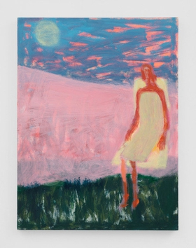 | Katherine Bradford  Favorite Seat  Acrylique sur toile (Acrylic on canvas)  101.6 x 76.2 cm (40 x 30 inches)  (BRADFORD-001) | € 49 000
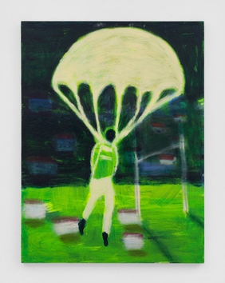 | Katherine Bradford  Parachute  Acrylique sur toile (Acrylic on canvas)  101.6 x 76.2 cm (40 x 30 inches)  (BRADFORD-002) | € 49 000
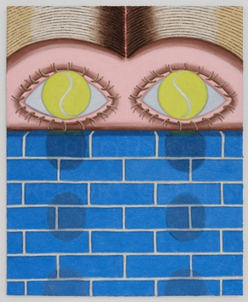 | Hamish Chapman  Parting with Blue Bricks, 2024  Huile et sqble sur toile (Oil and sand on canvas)  68.6 x 55.9 cm (27 x 22 inches)  (CHAPMAN-006) | € 5 275
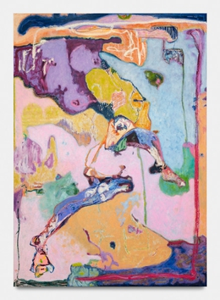 | Sarah Dwyer  Tu Sweet at Odyssey, 2024  Huile sur lin (Oil on linen)  186 x 132 cm (73.23 x 51.97 inches)  (DWYER-001) | € 24 265
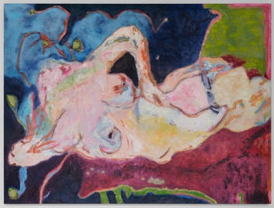 | Sarah Dwyer  In the Light of Time, 2024  Huile et pastel à l’huile sur lin  (Oil and Oil Pastel on Linen)  75 x 100 cm (29 1/2 x 39 3/8 inches)  (DWYER-002) | € 13 715
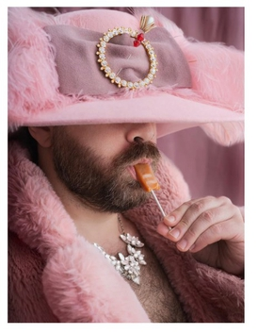 | Sean Fader  Sugar Zaddy, 2023  C-Print  101.6 x 76.2 cm (40 x 30 inches)  (FADER-001) | € 5 800
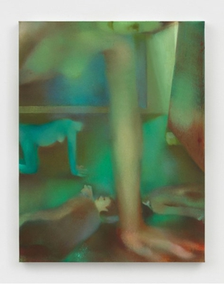 | Elizabeth Glaessner  Medusa, 2023  Huile sur lin (Oil on linen)  91.4 x 61 cm (36 x 24 inches)  (GLAESSNER-001) | € 24 265
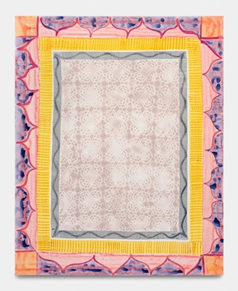 | Tamara Gonzales  Untitled, 2023  Acrylique; peinture en aérosol, et pastel sur toile (Acrylic, spray paint and pastel on canvas)  152.4 x 121.9 cm (60 x 48 inches)  (GONZALES-001) | € 17 935
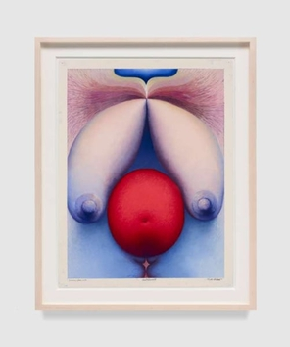 | Loie Hollowell  Full-Bodied, January 15, 2023, 2023  Pastel sur papier (Soft pastel on paper)  76.2 x 58.4 cm (30 x 23 inches)  (HOLLOWELL-001) | € 58 555
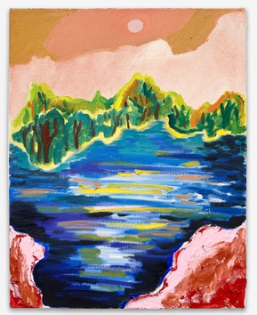 | Shara Hughes  Salmon Sky, 2021  Huile et acrylique sur toile (Oil and acrylic on canvas)  35.6 x 27.9 cm (14 x 11 inches)  (HUGHES-001) | € 78 100
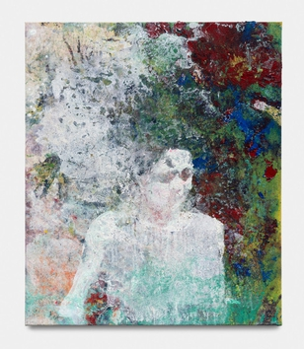 | Alexandre Lenoir  Flamme, 2024  Acrylique et huile sur toile (Acrylic and oil on canvas)  86 x 72 cm (33 7/8 x 28 3/8 inches)  (LENOIR-001) | € 31 650
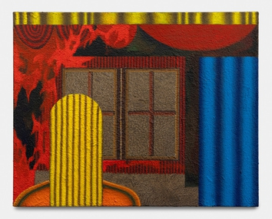 | Kevin Lowenthal  Collective Mannequin, 2024  Huile et coton sur lin (Oil on cotton on linen)  81.3 x 101.6 cm (32 x 40 inches)  (LOWENTHAL-001) | € 3 900
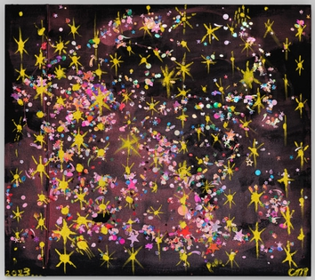 | Chris Martin  Untitled, 2023  Huile, acrylique; medium gel, paillettes sur toile (Oil, acrylic, gel medium, sequins on canvas)  101.6 x 114.3 cm (40 x 45 inches)  (MARTIN-001) | € 43 785
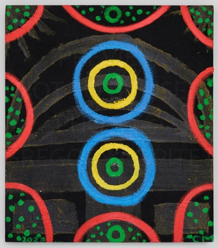 | Chris Martin  TAZ 5/20/2023, 2023  Huile et acrylique sur toile (Oil and acrylic on canvas)  61 x 53.3 cm (24 x 21 inches)  (MARTIN-002) | € 21 100
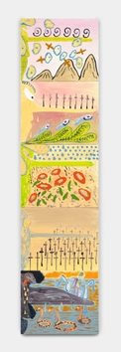 | Florian Meisenberg  Thus Spoke Zarathustra, 2024  Poussière de marbre et huile sur toile (Marble dust and oil on canvas)  41 x 51 cm chacun (each 16 1/8 x 20 1/8 inches)  total: 205 x 255 cm (80 1/2 x 110 1/2 inches)  (MEISENBERG-004) | € 21 100
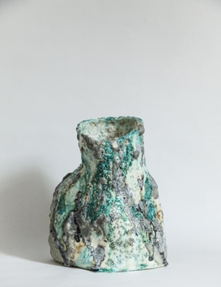 | Emily Orta  Icy Vase, 2023  Grès et émaux (Stoneware and glazes)  28 x 21 x 23 cm (11 x 8 1/4 x 9 inches)  (EORTA-001) | € 750
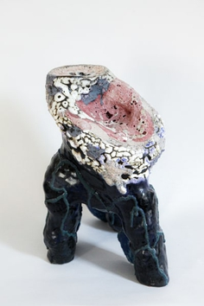 | Emily Orta  Lady Scalentrails, 2023  Grès et émaux (Stoneware and glazes)  35 x 24 x 22 cm (13 3/4 x 9 1/2 x 8 5/8 inches)  (EORTA-002) | € 3 250
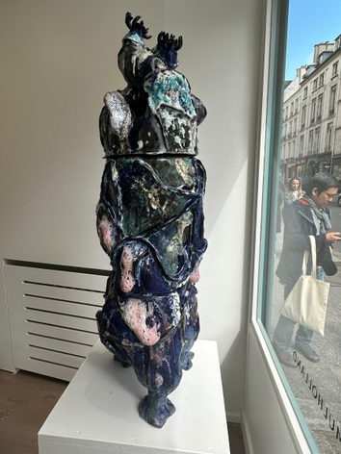 | Emily Orta  Oceanus, 2024  Grès et émaux (Stoneware and glazes)  98 x 30 x 34 cm (38 5/8 x 11 3/4 x 13 3/8 inches)  (EORTA-004) | € 8 000
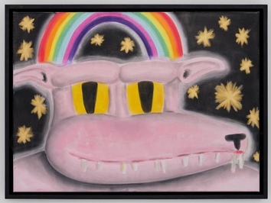 | Andrew Sim  Portrait of a Werewolf with Rainbows and Stars, 2024  Pastel sur toile (Pastel on canvas)  40 x 55 cm (15 3/4 x 21 5/8 inches)  (SIM-001) | € 12 135
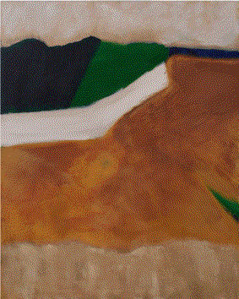 | Abbott Stillman  Flyover, 2022  Acrylique sur toile (Acrylic on canvas)  127 x 101.6 cm (50 x 40 inches)  (STILLMAN-002) | € 82 820
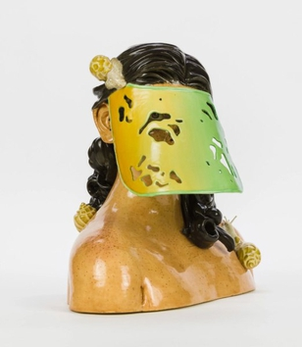 | Jessica Stoller  Untitled (visor bust), 2019  Porcelaine, émaux, peinture de porcelain (porcelain, glaze, china paint)  30.5 x 30.5 x 22.9 cm (12 x 12 x 9 inches)  (STOLLER-001) | € 13 715
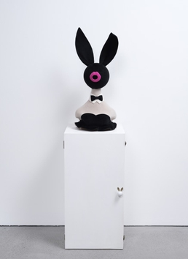 | Ryan Wilde  Classy Bunny, 2023  Feutre, bois (Felt, wood)  Sculpture: 83.8 x 40.6 x 40.6 cm (33 x 16 x 16 inches)  Pedestal: 91.4 x 45.7 x 45.7 cm (36 x 18 x 18 inches)  (WILDE-016) | € 13 715
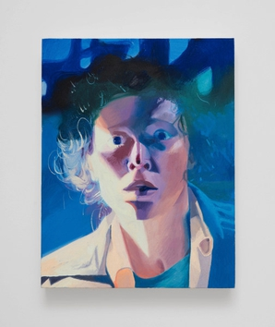 | Robin F. Williams  Abject Terror (Ripley), 2023  Huile sur toile (Oil on canvas)  66 x 50.8 cm (26 x 20 inches)  (WILLIAMS-001) | € 53 800
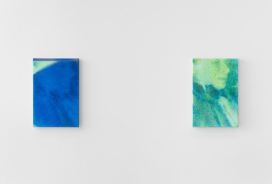 | Nana Wolke  00:02:17,038 - - > 00:02:24,350 (How a horse will run until it breaks) and Copy of 00:02:17,038 - - > 00:02:24,350 (How a horse will run until it breaks), 2024  Huile et copeaux de metal sur lin (Oil and metal shavings on linen), Huile sur lin (Oil on linen)  30.5 x 20.3 cm chacun (each12 x 8 inches)  (WOLKE-001) | € 6 860
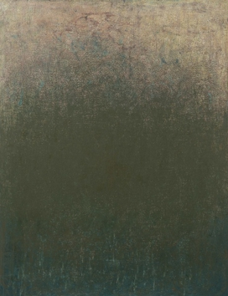 | Rebecca Purdum  Ripton 165, 2022  Huile sur panneau (Oil on panel)  68.6 x 53.3 cm (27 x 21 inches)  (PURDUM-001) | € 12 150

